**Introduction:**

University of Professionals, is an enterprise like East West University, owns a large number of computers, with a complex network infrastructure. Apart from wired internet access to all the classrooms, labs, employee PCs, library and other administrative and academic wings, the university also provides wireless internet access for everyone. On top of that the university runs a number of complex networked systems to support several of its business process like admissions, advising, results, eTender, library management, accounts and so on.

This complex network infrastructure is subnetted and switching/routing mechanisms are in practice.

**Tools Used:**

* Cisco Packet Tracer Software (version 5.3.3)
* Laptop-Pt, Pc-Pt
* Switches (2960)
* Routers (Generic)
* Access Point-PT (Wireless Device)
* Server-PT (Single Server For WEB, DHCP and DNS)
* Connectors (Copper straight through, Serial DCE)

**Tasks Done:**

* Web page of the university reflects University of Professionals’ web page because of all devices is connected to the server which is acting as WEB, DHCP & DNS server.
* DNS sever was installed to locate webserver which redirects us to the website of University of Professionals.
* Single DHCP server provides all of the required IP to all of the networks.
* Wireless links to the networks are available.
* University’s full network has covered its six campuses with six routers;
* Connectivity between all the hosts has been established.

**Network Diagram:**

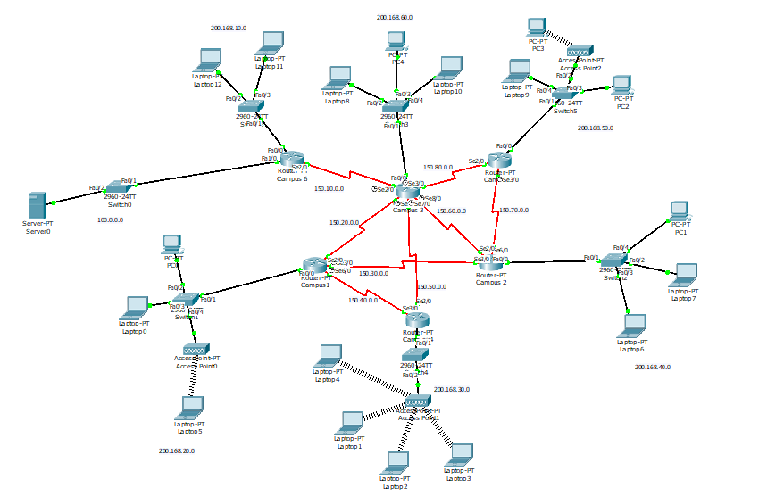

**Setup and configuration:**

I have used Class C network for the hosts (200.168.10.0, 200.168.20.0, 200.168.30.0, 200.168.40.0, 200.168.50.0, 200.168.60.0), Class B networks for Router’s Connector networks (130.10.0.0, 130.20.0.0, 130.30.0.0, 130.40.0.0, 130.50.0.0, 130.60.0.0, 130.70.0.0, 130.80.0.0), and for Server network I have used class A network 100.0.0.0.

\

For The Router IP Setup We have used a CLI code for each router,

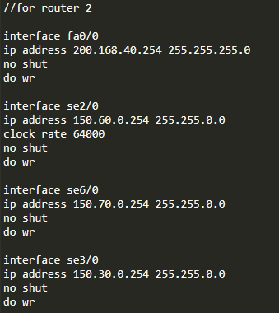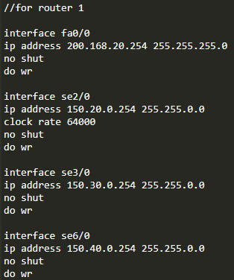  
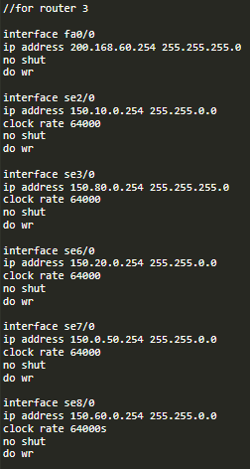 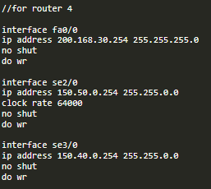

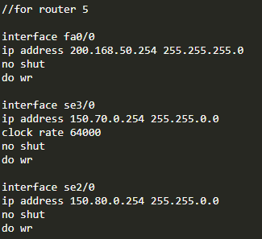 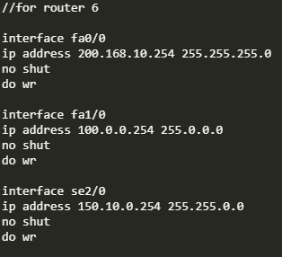

To setup the Routing Table I have used the following CLI Code,

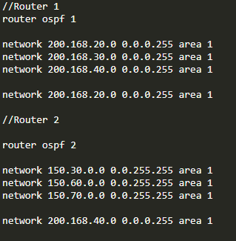 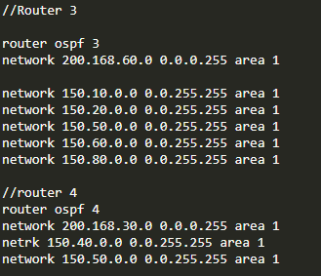

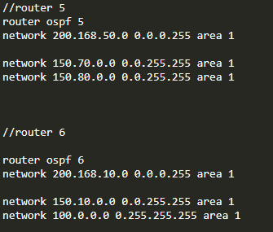

To establish connection between the server with all the other networks, I have used IP helper address as it’s a remote DHCP for other networks.

We have set the IP of the server to 100.1.0.0 and set the helper address to all the interfaces as cli code,

**IP helper-address 100.1.0.0**

**Server Setup:**

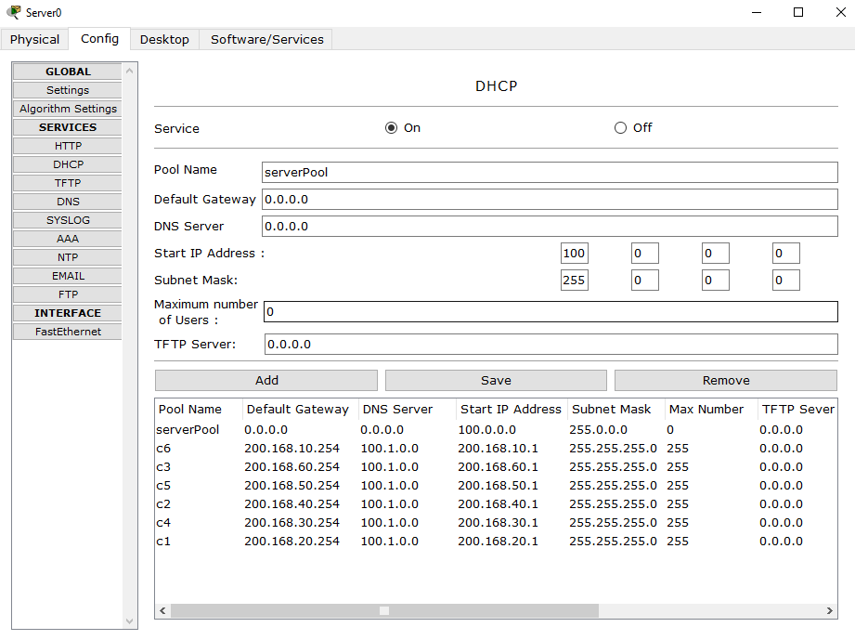

Here, we have made some pools that would generate the IP range for different networks In the DHCP server.

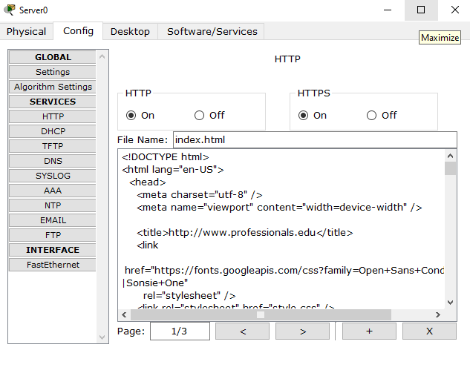

This will work as out http server and run the page index.html.

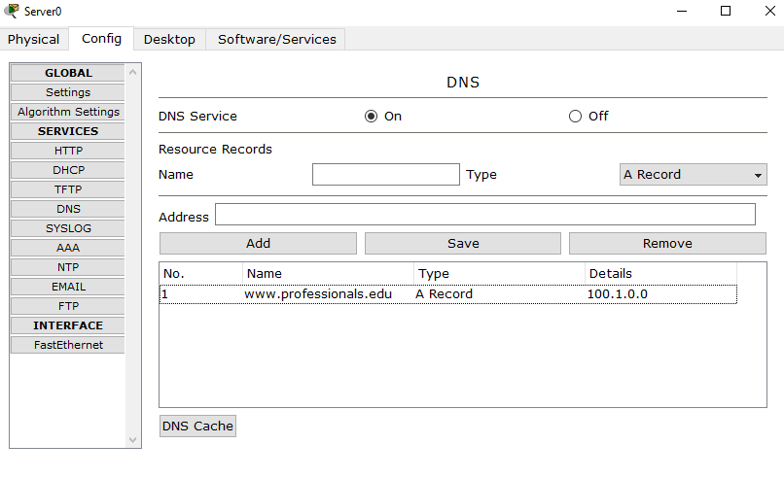this is the DNS server.

**Running the webpage from a PC:**

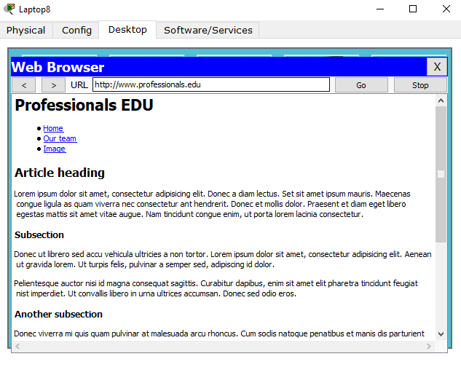

**Establishing The Connection between hosts:**

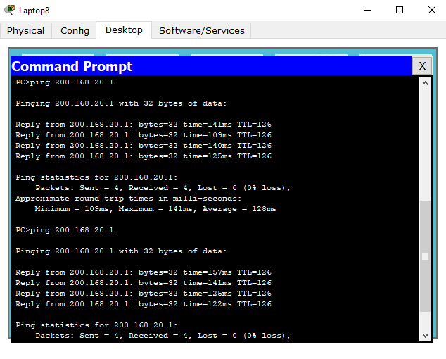

**Limitations:**

There were a lot of bugs I have faced during the design of the network which is surely the limitation of our project, especially when designing wireless devices it would automatically connect to the first wireless device even if we use connect the device to other wireless device.

**Conclusion:**

Using OSPF network architecture helped me to configure the routers easily, I could also use wireless routers but because of great complexity and lack of knowledge about wireless routers I have not used that here. Furthermore, There could be 3 different servers instead of one for DHCP,WEB, and DNS respectively but I preferred using one server for 3 services.